SOFTWARE PROJECT REPORT TEMPLATE

(Python – Habit Tracker)

Title Page
Project Title: Habit Tracker Application
Student Name: Yaseen Dawlatzai
Module Code: CST0400
Academic Year: 2025/26
GitHub Repository: https://github.com/dawlatzaiyaseen302-ai/Habit-Tracker-Application-Project.git

1. Problem Definition
Describe the problem your software solves.
• What is the real-world problem?
My software is a habit tracker application which indicates that a real-world problem is the unhealthy habits that an individual is committed to. This is because habits usually create a character in an individual, such as addiction. Regarding this, my habit tracker application creates different types of questions that a user is supposed to answer. My habit tracker is considered useful because it’s like a journey for somebody to replace their bad habits with good habits. Thus, the habit tracker application is all programmed via python.

2. System Overview
Describe what your system does.
1. Add habit
The first part of my system is the part where the user can apply a habit to their tracker. My system can often recognise this mostly through an input, because it occasionally acts as a guideline to collect answers from different users. For example, the “Enter a habit:” command for the user allows a user to answer any generic habit that leads to the data to be collected.
2. Log progress
Next is the second part of my system is the part where a user can log their progress to their tracker. This is because it is important that a user can update their tracker. However, this can only work when the data is existing otherwise it wouldn’t if a user hasn’t got any habits.
3. View habits
Then there is a third part of my system that can allow a user to view their habit list. This is because it allows a user to remember their habits, so that they won’t forget their habit information.
4. Show summary
Lastly in the fourth and final part of my system, is when a user can look through their progress of information or data about their habit. This is important because this allows them to not forget or lose track of their habits, otherwise it could lead to a downfall, which would lead to a user finding out the hard way in stopping their habits. Overall, the summary should be in any habit tracker that a developer is making.

3. Data Design
Explain how data is stored (What data structures are used to store data and why)
In my habit tracker, data is stored through dictionaries or lists. This is because I want my application to recognise a key which is the habit name and the value which is like the number of times that a habit is undertaken. When it comes to the data, it is like an indicator for the program to recognise a key from this function. For example, Eating Healthy : 7, is a key with a value as mentioned further.

4. Functional Design
Explain the functions used:
1. add_habit()
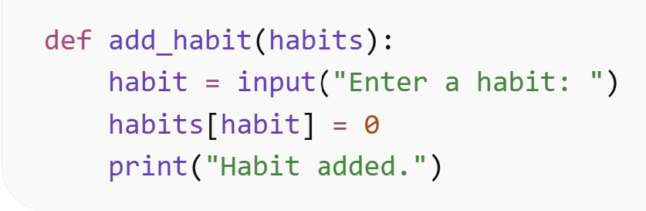
This function means that a user can apply a new habit. This is when it asks the user to name a specific habit or any. As it is shown on the “Enter a habit:”. The reason I put this is because I want a user to start with a question that they’re given instead of any question that they might possibly struggle to think of, when finding a way to stop the wrong habits.

2. log_today()
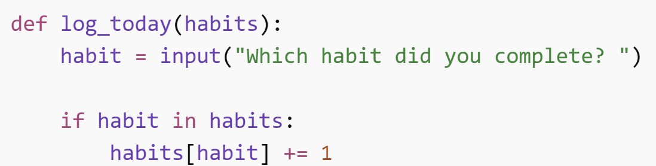
Next this function means that a user can answer which habit they’ve completed. This is crucial because a user can select an existing habit of their choice, which shows that a user can keep up with their hard work in their progress, so they could prosper by replacing their bad habits with good habits.
3. show_habits()
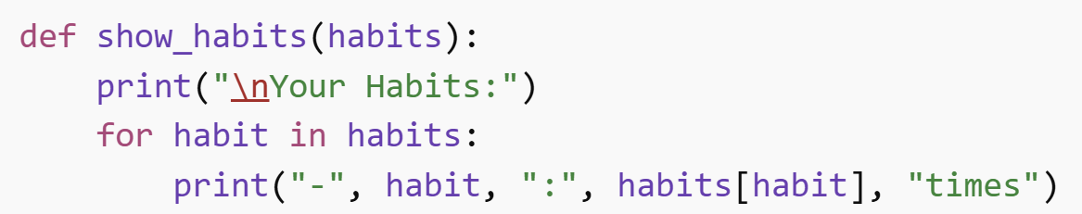
Furthermore, the show_habits function means that a user is tracking their habits that’s been displayed or used by the function. This is a great way for the user to keep in track or focus on their habits. It shows that the function is in a loop, so it’s basically repeating information that’s been used in the dictionary.

4. show_summary()
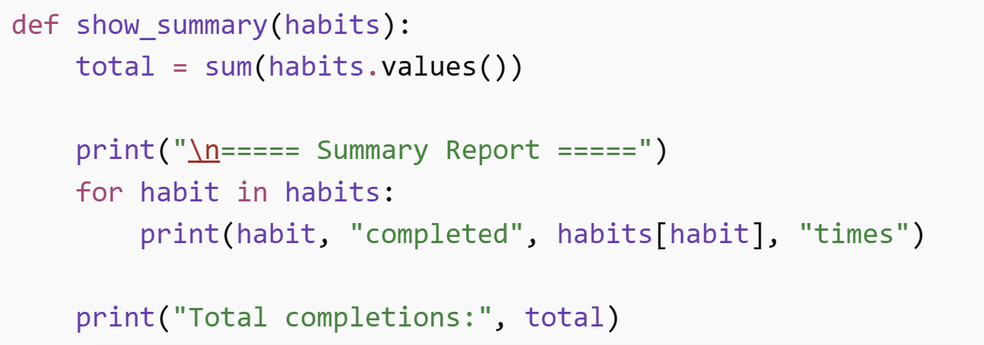
Then, in this function of my habit tracker shows a summary report of a progress for each habit and the amount of times a habit has been addressed as a total. So if the user felt as if they’ve accomplished their milestone, then for my application, I’d essentially recommend them to use it only after they’ve completed replacing their bad habits with good habits.
5. save_habits()
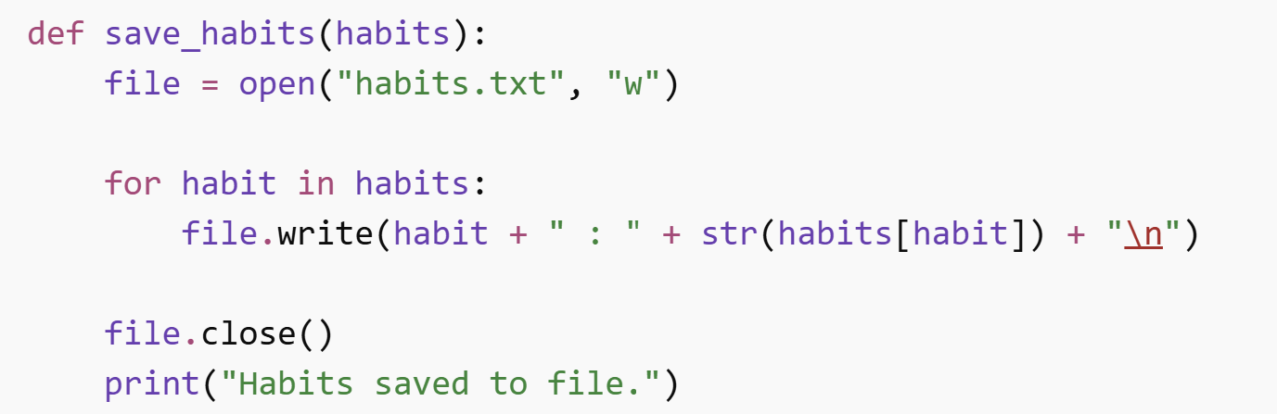
Lastly, this function is responsible for saving a report for a user’s habit tracker summary or result. This is important because when a user’s data is saved, it could be sent in their computer files, where they could see their statistics visually clear and precise, making it especially less overwhelming for them.

5. Program Flow
Explain how the program runs:
Start → Menu → User Choice → Function → Loop?
First, when the program runs which is like the beginning or the first step for the code to operate, it must be saved before trying to apply the program, so it could allow a user to go in the next steps. Then in the menu step, a user will be given a display of options by choosing a number especially 1-5 for them to desire, and answer the numbers themselves. Furthermore, in the user choice step, a user will be given a series of questions especially when they want to add a habit, the questions will usually ask them the amount of times they done this habit and it will display an answer made by the program numerically. Next in the functions, this step is crucial because without it the program will be in errors or would end quickly, and it actually means that the user has selected a task based on the user’s menu choice. Lastly, the loop means that the code repeats itself over again until the program’s condition varies.

6. File Handling
Explain how data is saved using open() and write().
Once data is saved or processed buy the user, the information will be sent to the user’s PC drive, as it allows the program to have access in making a small report or summary of the user’s habit. This data save will likely be in the notes of someone’s habit tracker progress. For example in the image shown, the program calculates the user’s target or total to make an overall completion of their habit. Overall, this could be saved through “habits.txt”.
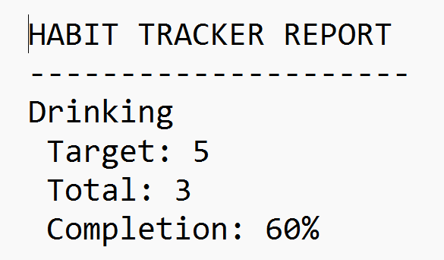

7. Testing
Describe how you tested the program.
Include simple test cases.
I’ve tested my program through various methods, which includes having to run the program several times. In this method, it allows me to pay more attention to the detail of the program. For example, if I had a missing string the system will tell me, I even used a python option could allow me to check the number of lines in the script, so I could quickly mitigate an issue with my code. My second method where I asked my peers, the issue of my code, because I believe that when communicating it creates or establishes relations that could essentially make a task easier to solve, so that it won’t be difficult later on in future projects.

8. Error Handling
Explain how invalid inputs are handled.
The invalid inputs are handled through detection at first, which the right way for any software developer to detect an issue with their application, then they can research the problem and then just remove any parts of the inputs that may have bugs or issues to the application. For example, if an input is habit = blue, then that is wrong and inappropriate for the habit tracker. So essentially, it is strictly advised that a developer must test or find issues to their application as much as possible, if it leads to the issue to be mitigated.

9. Limitations
Describe current limitations of the system.
There can be several current limitations to the system of my application. Firstly, the program does save the habit statistics to the file, however, it does not load the habits that have been saved before, which may be an issue for the user as it leads to lose their progress, if it doesn’t include any file reading functions into the script. Next, the program is often loaded with questions, which may dissatisfy user interests with the application, as the CPU only speaks in questions mostly especially when it’s not visually appealing. Then another limitation includes preciseness of the user’s habit, which unfortunately makes it inconvenient for them to write their habits, for example capital or lower case letters in the program, even with spelling mistakes, which may mean that their progress will be hidden. Additionally, the habit tracker doesn’t have calendar-style targets, as it is explicitly shown that the habit tracker only needs weekly progress or their total data and information. Usually in this scenario, it would lead users to have their habit streak or progress wasted. Lastly, the application isn’t eye-catching, nor does it have any notifications, visual graphs or advanced data storage methods including JSON, which may improve the user experience and further updates on the application for it to last a while.

10. Conclusion
Summarise what was built and learned.
In conclusion, this project is programmed using python, which successfully developed a habit tracker application, where the application asks the user for their name, weekly targeted habits, and when they would like their data to be logged or having an overall summary. The data is usually saved through a text file, so users can see an organised version of their data that they’ve applied to. The script has functions including; variables, dictionaries, loops, functions, conditional statements, file handling, and percentage calculations. The project has also been tested multiple times to find a real problem to the situation, mostly Python detects an error to the code such as a string that is missing, and often I’ve used AI to assist me in building this habit tracker that I also use to understand different functions. Furthermore, this coursework has helped me gain major understanding about my computing skills that I would potentially use in the future.

11. Future Improvements
Suggest improvements such as JSON, GUI, or graphs.
In my improvements that I am willing to outline and implement is highly recommended. This is because if I use JSON or GUI, then the user experience will be a lot better than a basic habit tracker that’s only command based. Furthermore, Graphs are considered to be non-linear because it means that the data structure allows the developers to have various paths to get from one vertex to another vortex, which is different to linear data structures such as Arrays or Linked Lists. Overall, these recommendations or improvements can be visually appealing for the user when having an application differentiated to this project.

12. References
List resources used. To what extent was AI used, if so, and what did you learn from it?
Overall, for this project I have used AI to assist me most of the time as it helped me have time management when meeting a specific deadline, and it increases my memory to understand various functions. Then, I’ve even done my research on python functions through w3schools.

Reference List
https://www.w3schools.com/python/python_dictionaries.asp
https://www.w3schools.com/python/python_dsa_graphs.asp
https://www.w3schools.com/python/python_variables.asp

